**Travel Day 0 10/15/2024**

After Andrew was done with school, and Tiffany and I concluded work for the day, we left for Minneapolis for our anticipated early morning flight.  Tiffany had already brought Willow to the dog lodge the day prior.  We normally take Hwy 169 but due to construction we opted for the Floodwood, Moose Lake, Interstate 34, route instead.

While traveling, we noticed the moon was almost full.  After checking, the moon will be full on Thursday the 17th.  Hopefully that’s a sign of good things to come:)

After stopping in Moose Lake for a break, Andrew stated he wanted to drive for a bit.  Andrew haven’t driven on an interstate before.  He drove for a bit and as it started to get dark out, he said he had enough.

We stopped in Forest Lake and ate dinner at Latin American restaurant called [Zoukmaya](https://www.zoukmaya.com/).  Andrew had beef tacos, Tiffany had a combo plate, and I had a beef chimichanga.  We all loved our food and the ambiance was enjoyable.  The inside had a lot of tree roots covering the walls and ceiling and lighting that followed the edges of pillars.

We then continued to our park & fly hotel located in Bloomington.  We stayed at the Holiday Inn and Express.  We all took showers and quickly went to bed.

**Seattle Day 1 10/16/2024**

We woke up at 4:30 am and got ready for our flight.  After taking the hotel shuttle to Terminal one, we found our way to gate F11.  Before boarding our plane, we ate breakfast at [Hi-Lo Diner](https://www.hi-lo-diner.com/).  Andrew had pancakes, Tiffany had a breakfast burrito, and I had the Fodero-two eggs over easy-toast-bacon.

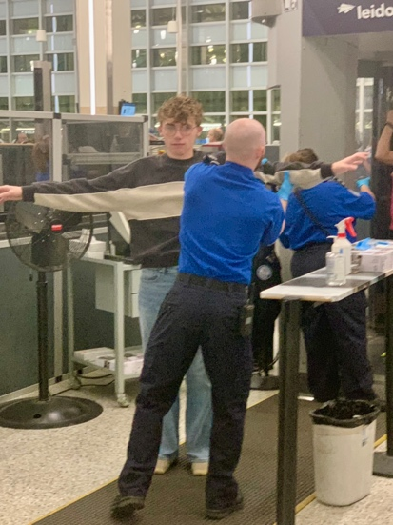

The plane we are flying in is a Boeing 737-900ER.  It travels at a speed of 525 mph and has a range of 2,870 miles.  I am currently sitting in seat 17E flying over Wyoming as I write this!  More to come.

We arrived at SeaTac and headed to the Link light rail station.  As we were walking to the station, Andrew found out he was selected to be second chair in the Grand Rapids High School Symphonic Band! What a great start to our vacation! Tiff and I were able to obtain Orca cards and paired them with the Orca app.  I forgot we needed to actually use the cards and we accidentally boarded the train without swiping the cards before boarding.  Whoops, Tiff then had to purchase tickets through the Transit Go app after a friendly reminder:) After arriving at West Lake station, we transferred to the Monorail, and then walked a few blocks to the Hampton Inn and suites.

After getting settled into room 352, Tiff and I walked over to Plaid Pantry convenience store and picked up a few items for our stay.  I purchased a 12 pack of [Rainier Beer](https://rainierbeer.com/), when in Rome...  We then left to explore Pikes Place Market. The weather was a lot better than we had anticipated, partly cloudy, warm, and a light wind.  We walked west down Pine Street and then turned south on Post Alley where we discovered [Pike Place Chowder](https://www.pikeplacechowder.com/).  We had a sample of chowder with sourdough bread!  I definitely want to go back and have chowder in the sourdough bread bowl.

We then headed into the market. We witnessed the throwing of fish had lots of salmon samples, and discovered a cool community garden area that has a great view of the bay. Lots of colors throughout the market, flowers, fruit, and seafood displays. We stepped out of the market and took a group selfie in front of the oldest remaining Starbucks. We then stopped at [Hellenika Cultured Creamery](https://www.hellenika.us/) and I tried the London Fog, it was delicious!  We then made our way down to the piers to get tickets for the Great Wheel.

[The Seattle Great Wheel](https://seattlegreatwheel.com/) located on Pier 57 is the largest Farris wheel on the west coast! We all had a blast and the views were amazing! I love it when a tourist attraction brings out the kid in you☺

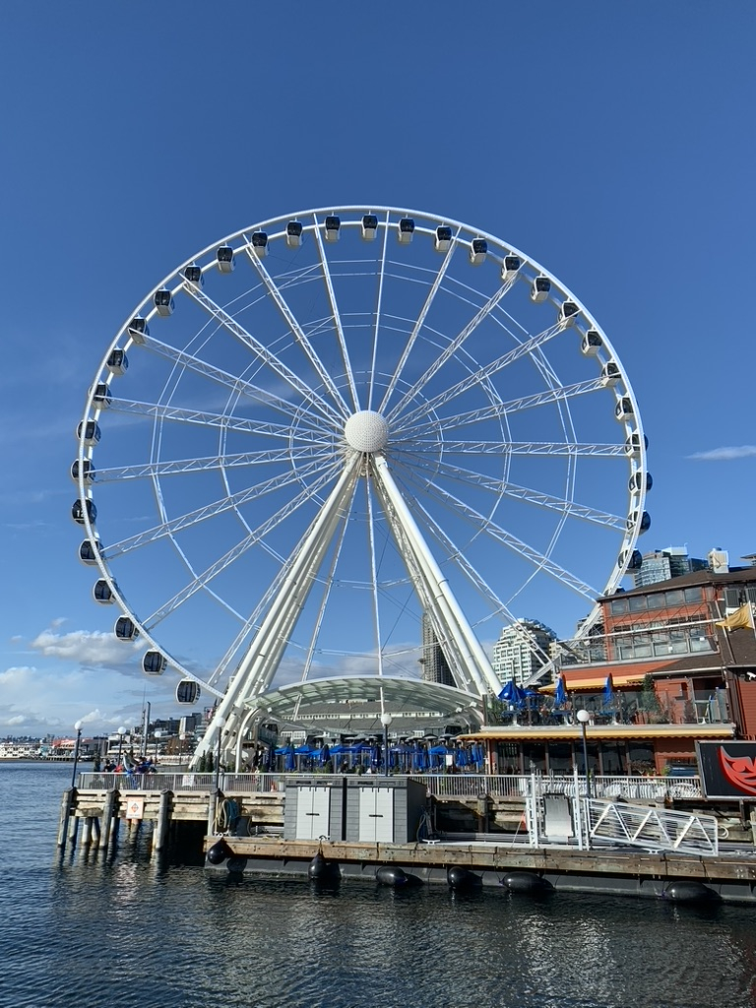

Because the weather was nice, we decided to move up a boat tour with [Salish Sea Tours](https://www.salishseatours.com/) also located on Pier 57 by a few days. The tour Eliot Bay consisted of narration of the Seattle skyline, tour of the shipyard, traveling out into Eliot Bay to the north and then a continuation of the skyline until we returned to Pier 57. Of course, Tiff and I enjoyed a cocktail along the way and took lots of pictures. Andrew was a bit chilled but had a great time nonetheless.

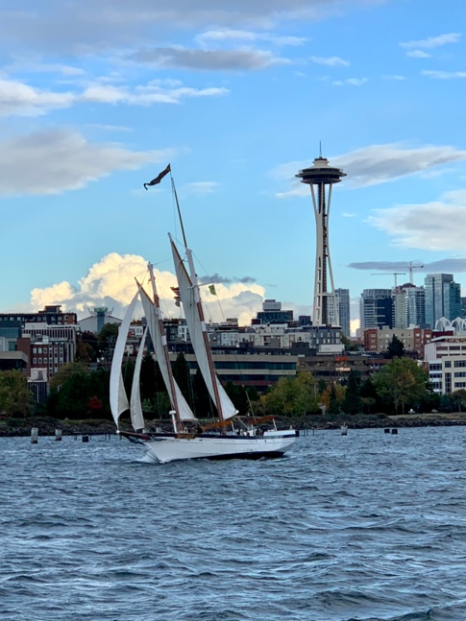

After the boat tour, we returned to Pikes Place Market and visited World’s Oldest Comic Shop, [Golden Age Collectables](https://goldenagecollectables.com/). They have movie scripts for sale which was cool. Andrew picked up a souvenir and we then continued on our way. While we were looking for a place to eat, we stumbled upon the infamous [Gum Wall](https://www.pikeplacemarket.org/vendor/the-gum-wall/) off near Pike and Post. It was getting dark so we made it a point to visit another day. Due to places closing early at the Market, Tiffany and Andrew opted for Greek food and I had a great bacon cheese burger at [Caliburger – Taco Del Mar](https://caliburger.com/) located in the Westlake Center Mall. We then took the Monorail back to our hotel and settled in for the night.  Everyone was exhausted.

**Seattle Day 2**

Tiff and Andrew woke up at 530am and I didn’t get up until 7am.  We went to Seattle Center and toured the grounds.  Andrew got a chocolate croissant and pumpkin bread at the Starbucks located within the Armory, this would be the one and only visit to a Starbucks.  We then went up the Space needle.  It was partly cloudy and the visibility was great.  I could see the entire Monorail route, I5 cutting through the city, and a couple of big spider murals on the roof of one of Seattle Center buildings.  The viewing platform has angled plexiglass panels that you can lean against :0 also interesting to see the small electric motor that rotates the dining area once per hour.  Very similar to the rotating restaurant in Duluth.

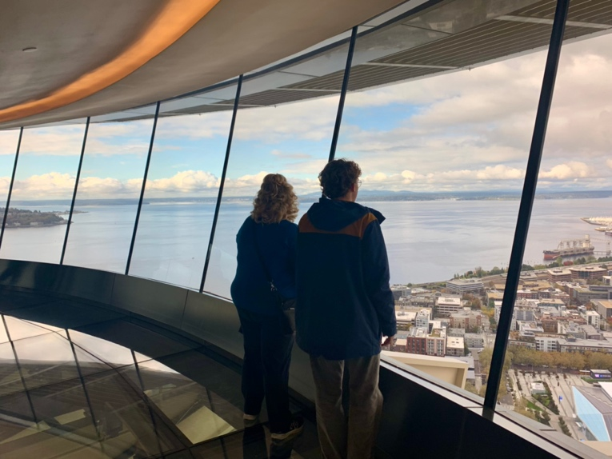

After trying to figure out the Orca card, I decided to buy two day passes on it because we were going to take the ferry to Bainbridge Island.  Turns out the State of Washington that runs the ferry doesn’t take Orca cards.  We haven’t had a lot of luck figuring out how effectively use the Orca card.

We then boarded the Monorail and headed to the Bainbridge Ferry.  While walking on Pine Street, we came across a large group of individuals using drugs in the open.  It’s eye opening to see so much of this activity.  Also, odd to not see any Seattle Police patrolling the downtown area. After making our way through a bit of rain mixed with maybe snow, we arrived at Seattle’s Colman Dock, Pier 52, bought our tickets, and boarded the ferry.

The ferry terminal on Bainbridge is located in the city of Winslow that overlooks Eagle Harbor. As we approached the ferry terminal, I noticed a large ferry maintenance area in the bay. After debarking, we walked down Winslow Way East, then up Madison Avenue South to [Proper Fish](https://properfish.com/). We all ordered the British Fish and Chips that came with a side of Mushy Peas. The Cod used for the fish and Chips is local caught from the Pacific Ocean.

We then browsed a few shops and Andrew and Tiff had ice cream.  We then made our way down to the waterfront to [Pegasus Coffee](https://pegasuscoffee.com/).  Pegasus Coffee is located within a building that was used to register Japanese Americans during WWII. I fell off the wagon and ordered a 12 Oz dark coffee.  It was delicious, stimulating, and hot!  As I enjoyed the coffee, we walked along the Charles Schmid Waterfront Trail.

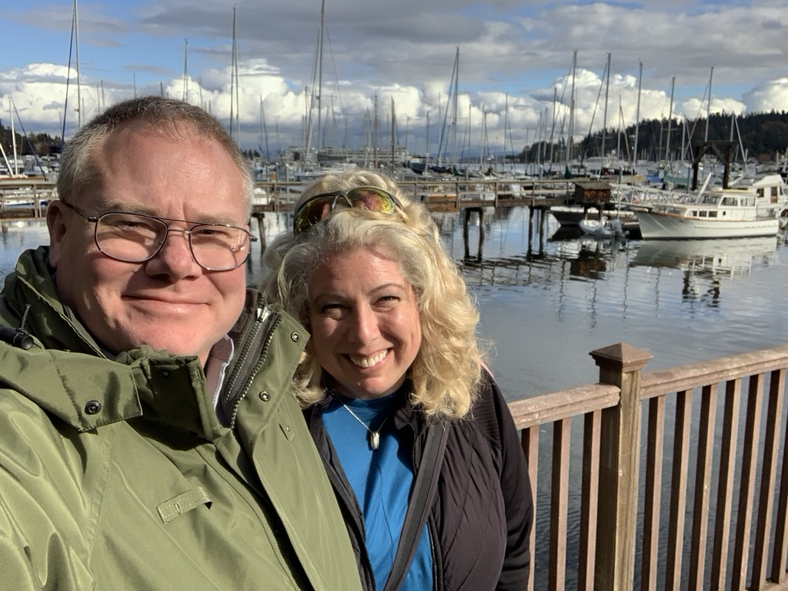

After enjoying the island, we took the ferry back and browsed shops at Pike Place Market.  We stopped again at Golden Age Collectables and briefly looked through a couple of other shops.  We then made our way to the famous Gum Wall and took a few pictures. Andrew and I both chewed some gum and added to the collection☺

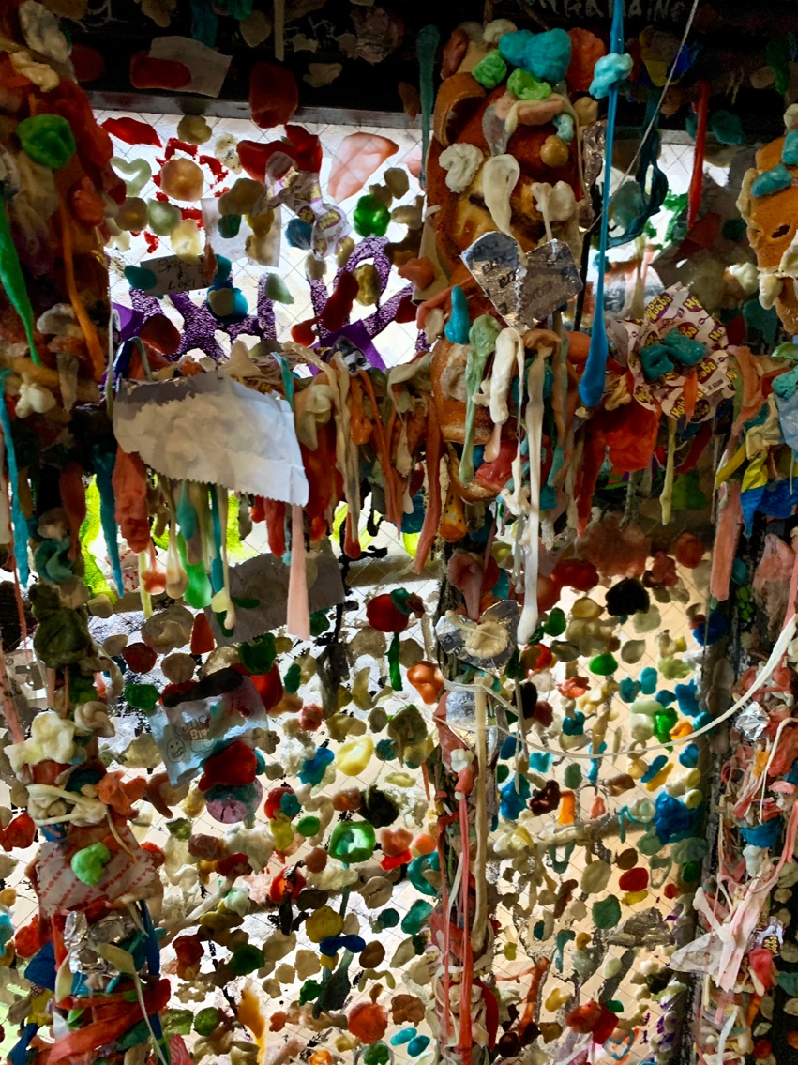

We then walked to 5th Avenue and Pine where Andrew got a new zippered hoody UniQlo and Tiffany got a more comfortable pair of shoes at Nordstrom rack. We then boarded the monorail and stopped at the space needle gift shop where I bought a pressure injected space needle from the Mold-A-Matic for $5.00.

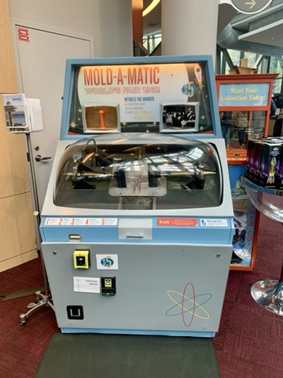

After returning to our hotel room to rest our feet, we returned to the space needle after dark to take in the Emerald City lights!  We could see a cluster of tall buildings off to the east that is Belview. I think observation decks are better at night. After departing the Space Needle, we walked to [Big Mario’s Pizza](https://bigmariosnewyorkpizza.com/), picked up dinner, and returned to our room.  Our feet were done. Tired feet, 🦶 need to work out more.

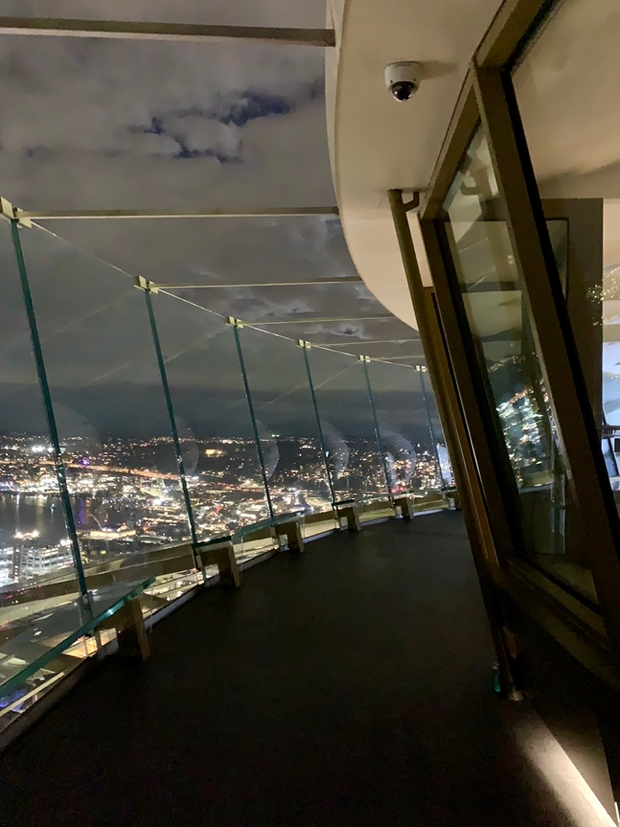

**Seattle day 3**

We started the day by attempting to do some last-minute planning.  Adjusting to a moving timeline during a trip can be stressful but we moved along and the day turned out perfect.  Andrew and I collected some breakfast items from the hotel lobby and brought them back to our room.  After breakfast, we hailed a Lyft and made our way to Marlyn and Gordon’s.  On our way, Tiff and I noticed a seafood restaurant located on the south side of Lake Union called [Duke’s](https://www.dukesseafood.com/locations/lake-union/).  We both looked at each other and without a word, Tiffany made reservations.  This would turn out to be a win!  As we were traveling, it started to rain fairly heavily but ultimately the weather for the day settled down and was just fine.  At approximately 11:00 we arrived At Marlyn and Gordon’s, 1906 Federal Ave E.

Gordon gave us a tour of their beautiful home, which spans three floors. The first-floor outdoor area had a striking design that reminded me of architectural elements from the movie Ex Machina. He showed us a back office that he once used for meeting patients when he was practicing psychiatry. Gordon later mentioned that he still meets with his colleagues once a week. Outside in a walk-out area from the office, he pointed out a gorgeous fuchsia plant that had a hummingbird feeding from its nectar. On the second floor, the kitchen opens onto a cozy back deck. In-between the kitchen and back deck is a charming fireplace that their cat, Miko, particularly enjoys. The third floor features a front deck with a stunning view of the Space Needle.

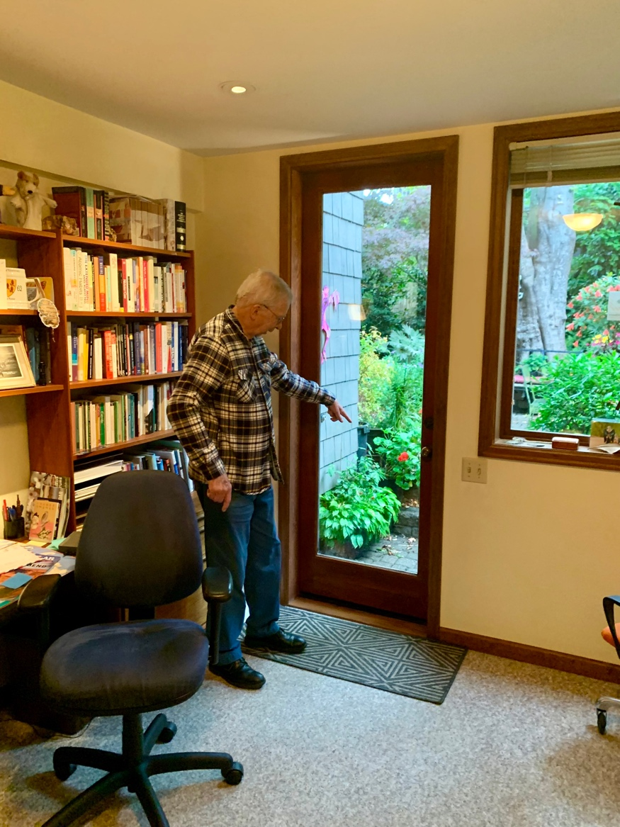

Marlyn showed Andrew some of her knitting, and the two also took a ride in their elevator, which was cleverly repurposed from an old steel-lined chimney. Their home is framed by perfect Pacific Northwest landscaping, complete with a beautiful dogwood tree. We took a group photo and then Gordon served us some delicious tea.

Gordon and Marlyn told us the Story of how they met in the 60’s. They probably used the First computer matching program ever made. Marlin had to finish her last class in Stanford that she got an incomplete in which was Shakespeare.  She wanted to meet somebody, so she participated in a matching study that used a computer that was programmed by some other folks at the University.  Gordon was also at Stanford and wanted to meet somebody that wasn’t a nurse.  The rest is history.

After finishing up our tea, Marlyn drove us to 104 14th Avenue to quickly see the apartment building I was born in.  On the way, I mentioned Gordon was a wonderful back seat driver.  I don’t think Marlyn had the same opinion:) Marlyn drove us south along the west side of volunteer park on Federal Ave East, went east up a good sliding hill on east Prospect Street, and then turned south on 14th Avenue East. As we drove through Capitol Hill, it was interesting to see the transition of large homes to apartments as we approached Denny Way.

The apartment that I was born in is located at the intersection of 14th Avenue and Denny Way.  After arriving, Marlyn stayed with the car and Tiffany, Gordon, Andrew, and myself got out to take a quick look around and get a few pictures.  After Tiffany took a great picture of Gordon, Andrew, and myself standing in front of the apartment, we then left to eat lunch.

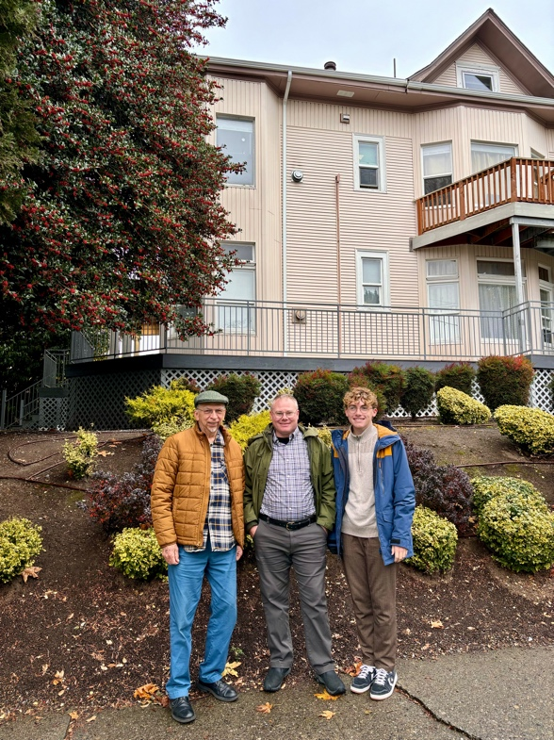

We ate lunch at a Vietnamese restaurant called [Monsoon](https://monsoonrestaurants.com/seattle/) located at 614 19 AveE. For an appetizer, Gordon and Marlyn ordered Spring Rolls and Spicy Green Beans. Andrew had the Lemongrass Chicken, I had the Lemongrass Beef, and Tiffany had a Combination. The food was delicious! For dessert, Banana Cake with a coconut cream sauce that was to die for.

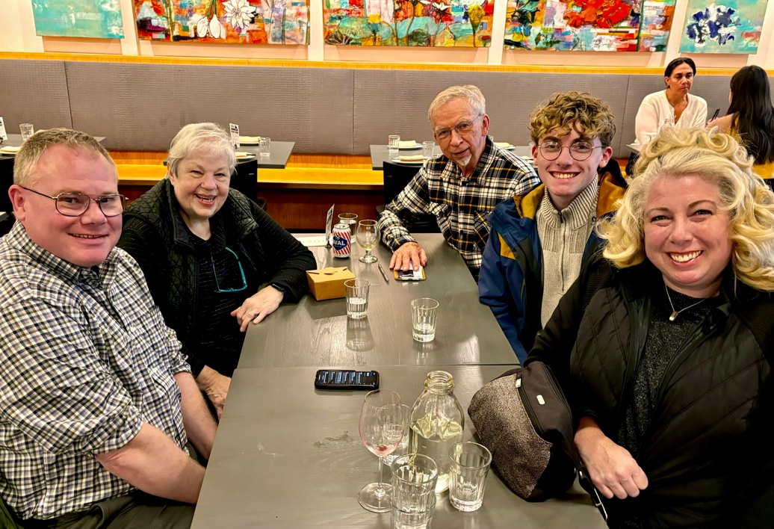

After eating lunch, we said goodbye to Marlyn and then dropped her off at their home, Gordon then drove us to the Japanese Garden.  As we bounced over a few speed bumps, Gordon humorously stated “There not speed bumps, there speed lumps;)”

The serene [Seattle Japanese Garden](https://www.seattlejapanesegarden.org/) is nestled within Washington Park Arboretum, a hidden Garden of Eden in the midst of the urban jungle. The overcast, cool, and humid weather highlighted the garden's natural beauty, with moss coating nearly every surface and spring-fed water flowing gently through koi-filled ponds. Fall's solid colors added richness to the landscape, enhancing the tranquil atmosphere as Andrew and Gordon made coin wishes. Gordon explained that the entryway had recently been rebuilt to better reflect the garden’s aesthetic and shared that, due to his deep love for the space, he’s considering becoming a part-time tour guide. The experience immersed us in the peaceful, authentic spirit of a traditional Japanese garden.

After visiting the garden, Gordon drove us down Madison Street to drop us off for our underground tour. Madison is the only street that runs between Lake Washington and Eliot Bay.  The street was recently rebuilt and has bus stops that are in center of roadway like light rail stops.  The bus lanes seemed a little confusing to many drivers and at one point a bus was in the regular traffic lane and we needed up in the bus lane.

After Gordon dropped us off in Pioneer Square, we checked in with the famous Bill [Speidel’s Underground Tour](http://www.undergroundtour.com/about/). We had a little extra time before the tour started so I grabbed a delicious cup of coffee at [Caffe Darte Italia Coffee Roasters](https://www.caffedarte.com/).

The underground tour took us beneath the streets at three different locations around Pioneer Square. Basically, the city burned to the ground, businesses didn’t want to wait for Seattle’s long-term plan, they rebuilt right away, then Seattle built the streets raising the ground level up approximately one floor. There was also exploding crappers, sky lights built into the sidewalks, rats (we actually saw a big dead one by the Space Needle), and a story about loggers skidding trees down a street which coined the term “skid row.”

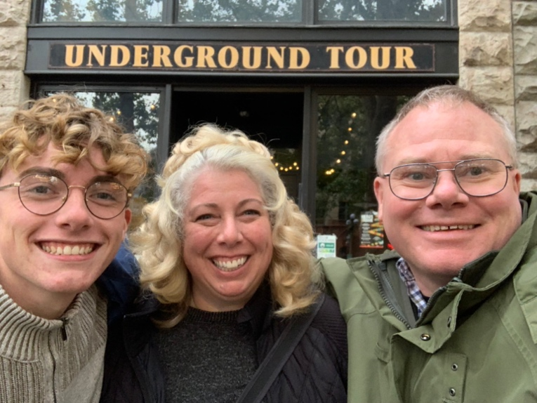 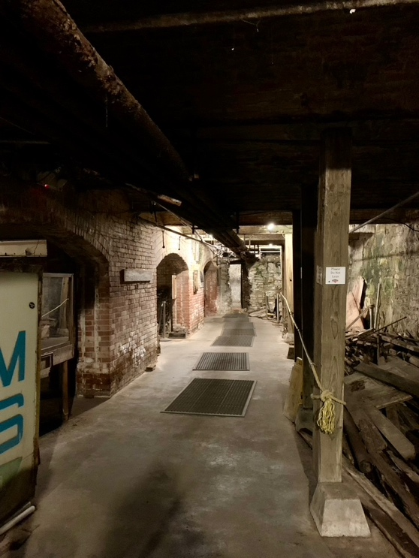

After the tour, we took a Lyft to [Dukes Seafood South Lake Union](https://www.dukesseafood.com/locations/lake-union/), 1111 Fairview Ave N, and had a fantastic seafood dinner. We sat outside on a patio overlooking South Union Bay towards Queen Ann. I had the Fresh Dungeness Crab and Prawn Stuffed Lobster, Andrew had Salmon Alfredo, and Tiffany had the Stuffed Halibut. For dessert we shared the Brookie Betty Boop. Dungeness crab was on my to-do list in Seattle and I was very happy with our food! After eating we then took a Lyft back to our hotel and called it a night.

**Seattle day 4**

After getting ready for the day, we left at approximately 1030 and walked to the [Museum Of Pop Culture](https://www.mopop.org/).  The first two exhibits that that I geeked out on were Special Agents Fox Mulder and Dana Scully’s FBI IDs from the show X-Files. And the second was the silk and snakeskin suit worn by Sean Young as Rachael in the film Blade Runner, 1982.  This exhibit along with the rest of the Blade Runner exhibits is courtesy of Paul G. Allen, co-founder of Microsoft.

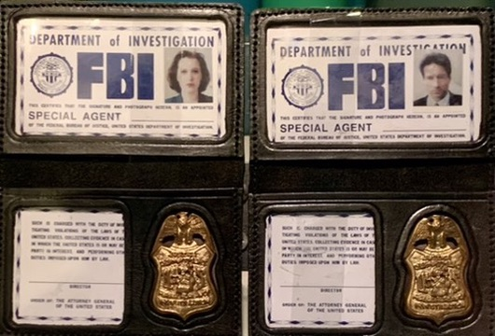

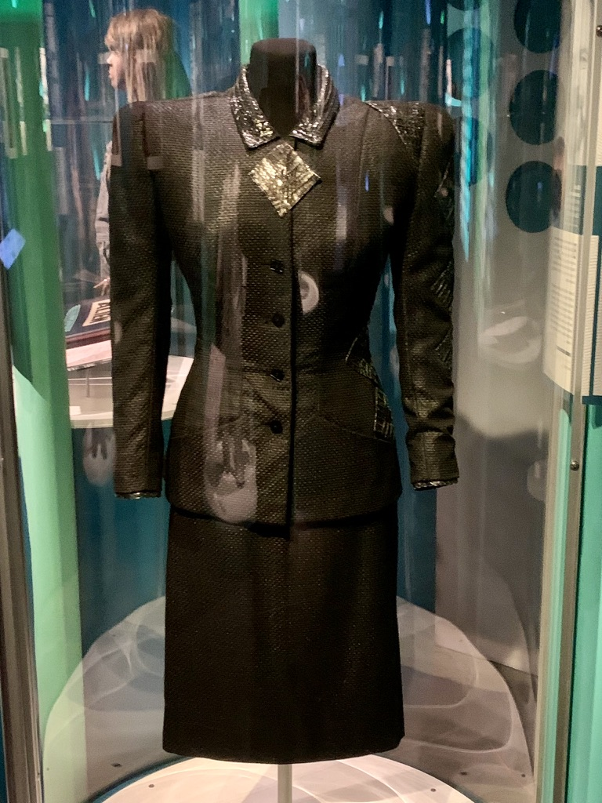

The Sci-Fi and Horror exhibit on the lower level was by far my favorite. The Sci-Fi exhibit had collections from Terminator, Blade Runner, Star Wars, Star Trek, and so many other movies and tv series collections. The Horror exhibit had Alien and other horror movie exhibits.

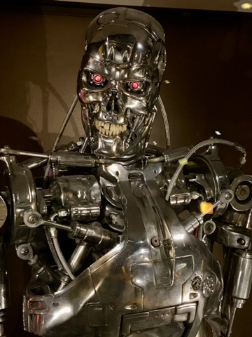 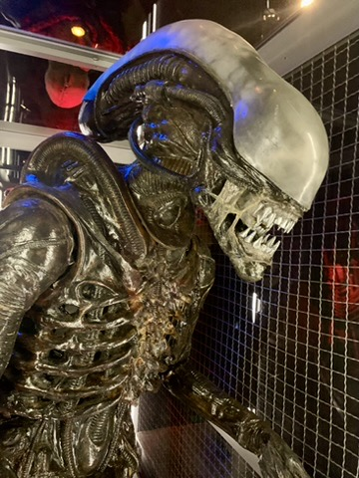

We visited the Nirvana, Jimmy Hendricks, and other pop culture exhibits. We had a great time listening to Andrew play some rifts in the Sound Studio.  We punched extra tickets and toured the Keith Haring exhibit.  Andrew said Keith was one of his favorite artists.  I am not real familiar with his work but I found it to be interesting.  Tiffany said we have a Christmas CD that has cover art from him.

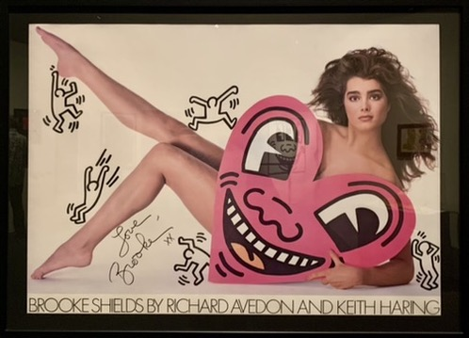

After the museum, we took the Monorail and then had Mac and cheese at [Beecher’s Handmade Cheese](https://beechershandmadecheese.com/) and chowder in a bread bowl across the street at [Pike Place Chowder](https://www.pikeplacechowder.com/), 1530 Post Alley. Both were absolutely worth the wait in line. We then left to walk to the spheres.

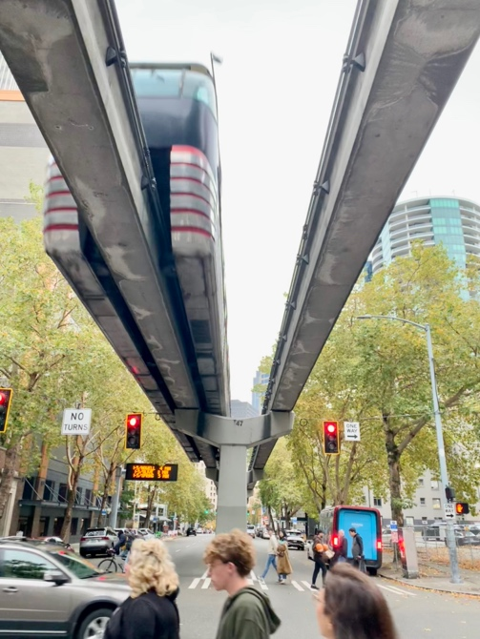

We arrived at Amazon’s [the spheres](https://www.seattlespheres.com/), produced our tickets, and provided photo ID. The security was tight and several people, including an employee who was attempting to use their work badge, were being turned away because they didn’t have tickets.  They only let the general public in twice per month, both days being on a Saturday. The spheres consist of several floors rising through glass spheres that contain and amazing indoor arboretum. The wall of plants was amazing.  The chairs on the top floor were very comfortable:). After giving our feet a rest, we left to make our way to the Columbia Center.

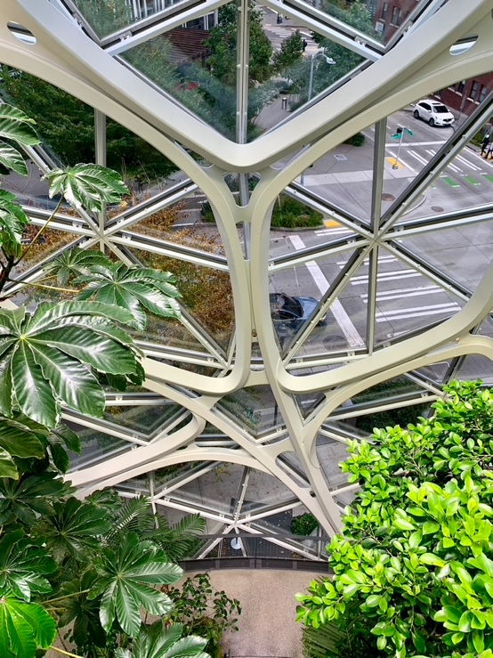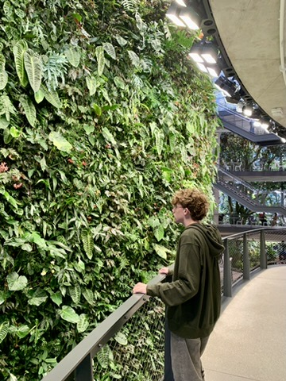

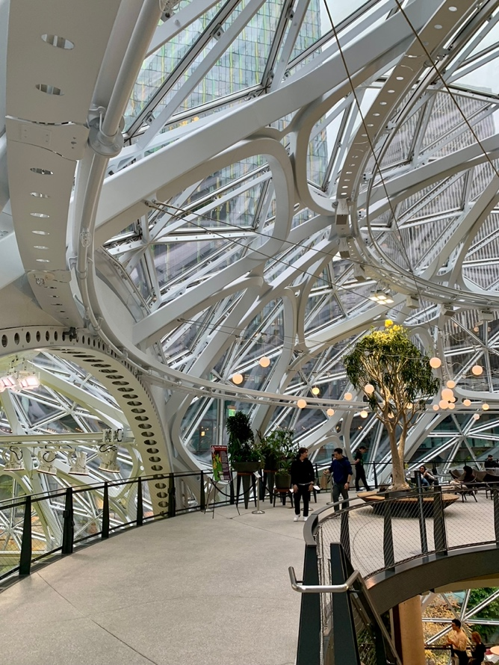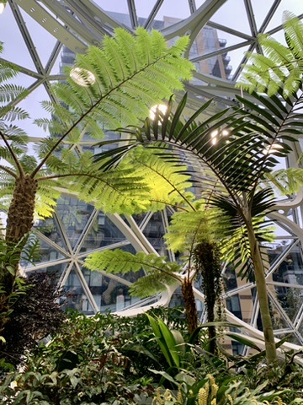

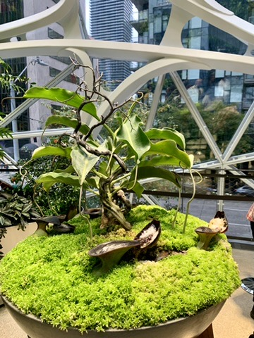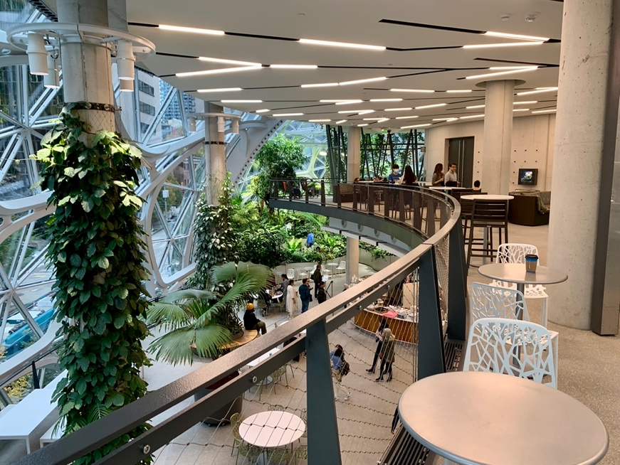

On our way to the Columbia Center, we walked into the [Seattle Public Library](https://en.wikiarquitectura.com/building/Seattle-Public-Library/) and took a peek inside at its modern futuristic architecture. We didn’t know a lot about the building but I was impressed with its atmosphere.

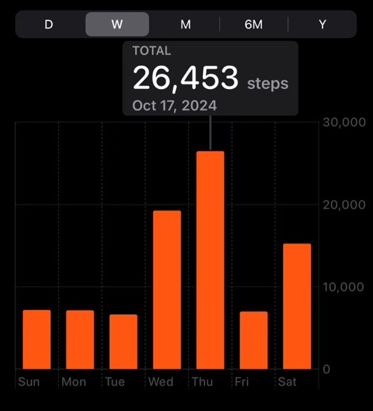

We then walked to the Columbia Center at which point Tiffany made it clear that we were done walking places☺ Of all major cities we have visited, Seattle has had the most walking. From 5th Avenue and Pine Street (Westlake Station) to the furthest popular attraction is approximately one mile. Anything further and I would take a Lyft.

We made our way up to the seventy third floor to the [Sky View Observatory](https://skyviewobservatory.com/). The weather was a bit overcast so the view wasn’t great but we could see all of downtown area and Elliott Bay. We enjoyed a couple of cocktails and were able to see the Seattle Sounders playing in Lumen Field. As it got darker, we were able to watch the stadium fireworks, lighting and effects.

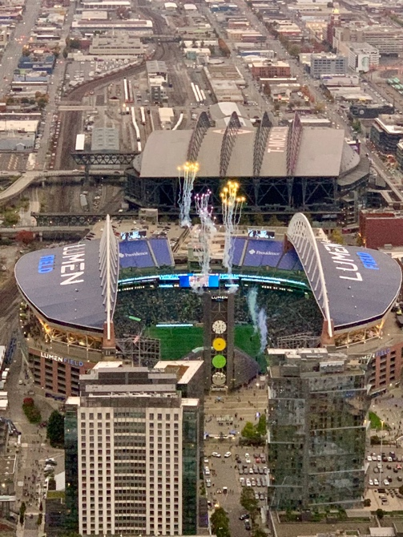

After leaving the Columbia Center, we walked out onto the sidewalk and a Lyft driver showed up and motioned for us to get in. There was nobody else standing around waiting to be picked up so I assumed it was ours. We then got into the Lyft, drove for a bit, and then figured out we had gotten into the wrong Lyft. It was my fault for not matching the driver’s car and face. The Lyft driver didn’t really know what to do so we eventually just canceled our ride on the application and then paid him cash after he had dropped us off at the [Historic Chinatown Gate](https://en.wikipedia.org/wiki/Historic_Chinatown_Gate_(Seattle)) in the International District.

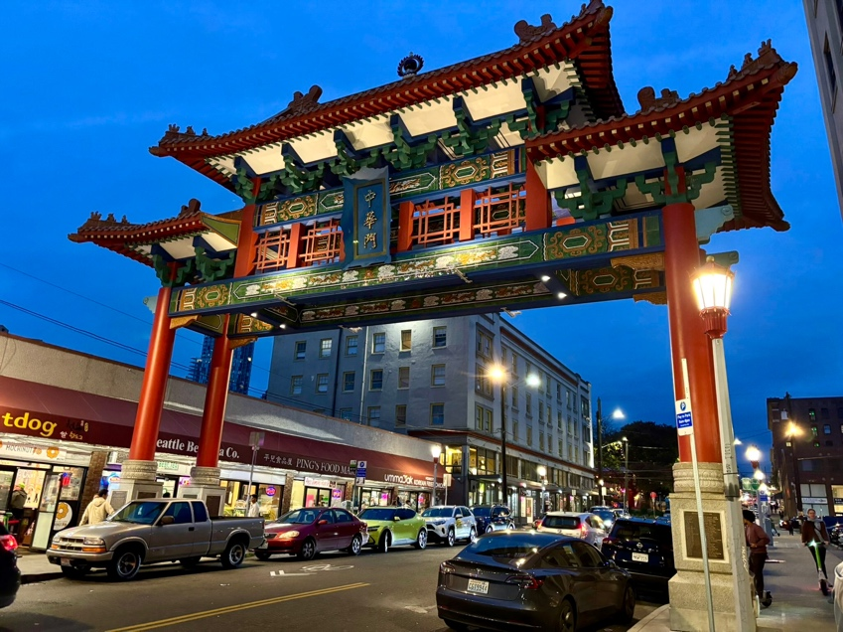

We had dinner at [Momosan Ramen & Sake](https://momosanramen.com/restaurants/seattle/) located near 5th Ave S & South King Street. Andrew and Tiffany had the Tan-Tan Ramen noodle bowl and I had Sticky Ribs and a Soft Shell Bao which was a bao bun, fried crab, lettuce, pickled cucumber, and spicy mayo.

After eating, we took a Lyft, being careful to get into the right one, back to the Space Needle to see if the Mold-O-Matic had its color changed, it was still orange so I will have to make a return trip☺ We then walked back to our hotel to get a good night’s sleep before leaving in the morning.

**Travel day 5**

We woke up at 5am Pacific time, finished packing, grabbed a quick complimentary breakfast, and called for a Lyft to the airport.

Our Lyft driver hopped on State Route 99 tunnel also called the [Alaskan Way Viaduct Replacement Tunnel](https://en.wikipedia.org/wiki/State_Route_99_tunnel) (a long tunnel that started near our hotel and then emerged on the west side of Lumen Field and the shipyard area). We then continued on to 509, 518, the AirPort Expressway, and lastly SeaTac airport. The Link light rail in combination with Monorail is nice but the Lyft ride was sure convenient and fast. The drive was approximately twenty minutes from the Hampton Inn to the Delta drop-off zone.  We then made our way through TSA and on to Gate B7A.

When we booked our round-trip flight, we selected our seats for the first half but must have neglected to select for the last half.  The gate agent said she would attempt to group us together and we ended up with seats 36A, 36B, and 37D.  First time sitting in the last row:) At least Tiff was able to have an isle row and Andrew got a window.  While we were preparing to take off, Andrew spotted Mt Reiner and was able to capture a couple of cool pictures.

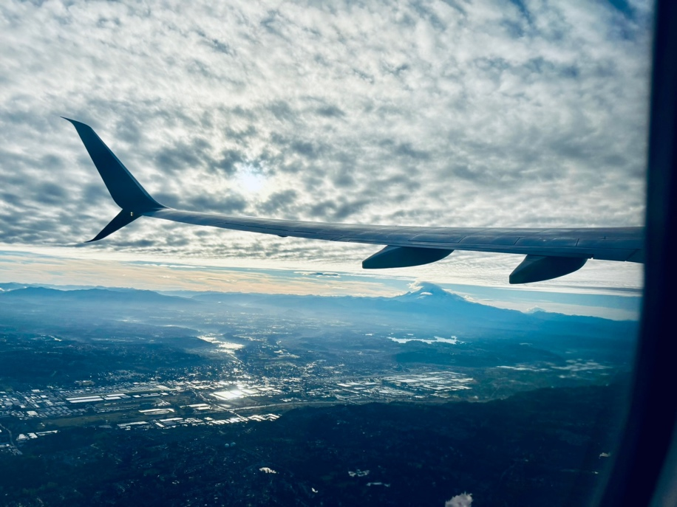

When we landed, it was 79 degrees in MPLS, yuk! While driving home, we stopped at Harry’s in Hill City for dinner. Steve and Deb got Willow from the Dog Lodge and brought her to our house. It was so nice to come home and see her after a great vacation!